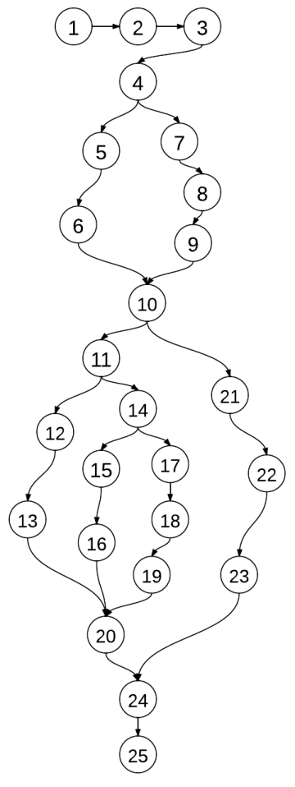**Java Code**

1. public int test(int a, int b, int c){
2. int s;
3. boolean IsTriangle;
4. if ((a<b+c)&&(b<a+c)&&(c<a+b)){
5. IsTriangle = true;
6. }
7. else{
8. IsTriangle = false;
9. }
10. if (IsTriangle){
11. if((a==b)&&(b==c)){
12. s = 1;
13. }
14. else if((a!=b)&&(a!=c)&&(b!=c)){
15. s = 3;
16. }
17. else{
18. s = 2;
19. }
20. }
21. else{
22. s = 4;
23. }
24. return s;
25. }

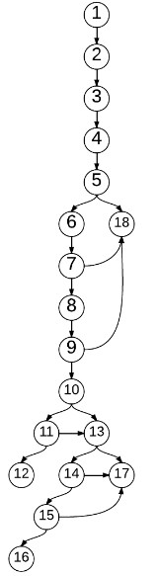**Jimple Code**

1. i0 := @parameter0: int
2. i1 := @parameter1: int
3. i2 := @parameter2: int
4. $i3 = i1 + i2
5. if i0 >= $i3 goto return 4
6. $i4 = i0 + i2
7. if i1 >= $i4 goto return 4
8. $i5 = i0 + i1
9. if i2 >= $i5 goto return 4
10. if i0 != i1 goto (branch)
11. if i1 != i2 goto (branch)
12. return 1
13. if i0 == i1 goto return 2
14. if i0 == i2 goto return 2
15. if i1 == i2 goto return 2
16. return 3
17. return 2
18. return 4

**Condition Extraction**

|  |  |  |
| --- | --- | --- |
| Node No. | Jimple Statement | Condition |
| 5 | i0 > i3; i3 = i1 + i2 | a >= b + c |
| 7 | i1 > i4; i4 = i0 + i2 | b >= a + c |
| 9 | i2 > i5; i5 = i0 + i1 | c >= a + b |
| 10 | i0 != i1 | a != b |
| 11 | i1 != i2 | b != c |
| 13 | i0 == i1 | a = b |
| 14 | i0 == i2 | a = c |
| 15 | i1 == i2 | b = c |

**All Path Coverage**

|  |  |  |  |
| --- | --- | --- | --- |
|  | Covered nodes | Input | Output |
| P1 | 1,2,3,4,5,18 | 17 5 8 | 4 |
| P2 | 1,2,3,4,5,6,7,18 | 4 9 3 | 4 |
| P3 | 1,2,3,4,5,6,7,8,9,18 | 8 11 22 | 4 |
| P4 | 1,2,3,4,5,6,7,8,9,10,11,12 | 22 22 22 | 1 |
| P5 | 1,2,3,4,5,6,7,8,9,10,11,13,17 | 6 6 4 | 2 |
| P6 | 1,2,3,4,5,6,7,8,9,10,11,13,14,17 | / | / |
| P7 | 1,2,3,4,5,6,7,8,9,10,11,13,14,15,17 | / | / |
| P8 | 1,2,3,4,5,6,7,8,9,10,11,13,14,15,16 | / | / |
| P9 | 1,2,3,4,5,6,7,8,9,10,13,17 | / | / |
| P10 | 1,2,3,4,5,6,7,8,9,10,13,14,17 | 17 23 17 | 2 |
| P11 | 1,2,3,4,5,6,7,8,9,10,13,14,15,17 | 9 16 16 | 2 |
| P12 | 1,2,3,4,5,6,7,8,9,10,13,14,15,16 | 33 25 27 | 3 |

**Statement Coverage**

|  |  |  |  |  |
| --- | --- | --- | --- | --- |
|  |  | Covered nodes | Input | Output |
| 1 | P1 | 1,2,3,4,5,18 | 17 5 8 | 4 |
| P2 | 1,2,3,4,5,6,7,8,9,10,11,12 | 22 22 22 | 1 |
| P3 | 1,2,3,4,5,6,7,8,9,10,11,13,17 | 6 6 4 | 2 |
| P4 | 1,2,3,4,5,6,7,8,9,10,13,14,15,16 | 33 25 27 | 3 |
| 2 | P1 | 1,2,3,4,5,6,7,18 | 3 11 7 | 4 |
| P2 | 1,2,3,4,5,6,7,8,9,10,11,12 | 30 30 30 | 1 |
| P3 | 1,2,3,4,5,6,7,8,9,10, 13,14,17 | 16 11 16 | 2 |
| P4 | 1,2,3,4,5,6,7,8,9,10,13,14,15,16 | 4 7 9 | 3 |
| 3 | P1 | 1,2,3,4,5,6,7,8,9,18 | 23 17 41 | 4 |
| P2 | 1,2,3,4,5,6,7,8,9,10,11,12 | 37 37 37 | 1 |
| P3 | 1,2,3,4,5,6,7,8,9,10,11,13,17 | 45 45 56 | 2 |
| P4 | 1,2,3,4,5,6,7,8,9,10,13,14,15,16 | 22 9 18 | 3 |
| 4 | P1 | 1,2,3,4,5,18 | 35 17 6 | 4 |
| P2 | 1,2,3,4,5,6,7,8,9,10,11,12 | 23 23 23 | 1 |
| P3 | 1,2,3,4,5,6,7,8,9,10,13,14,15,17 | 17 30 30 | 2 |
| P4 | 1,2,3,4,5,6,7,8,9,10,13,14,15,16 | 89 78 52 | 3 |

**Decision Coverage**

|  |  |  |  |  |  |  |  |  |  |  |  |
| --- | --- | --- | --- | --- | --- | --- | --- | --- | --- | --- | --- |
|  |  | D5 | D7 | D9 | D10 | D11 | D13 | D14 | D15 | Input | Output |
| 1 | 1 | T | / | / | / | / | / | / | / | 11 7 3 | 4 |
| 2 | F | T | / | / | / | / | / | / | 2 9 6 | 4 |
| 3 | F | F | T | / | / | / | / | / | 8 11 19 | 4 |
| 4 | F | F | F | F | F | / | / | / | 16 16 16 | 1 |
| 5 | F | F | F | F | T | T | / | / | 22 22 9 | 2 |
| 6 | F | F | F | T | / | F | T | / | 30 43 30 | 2 |
| 7 | F | F | F | T | / | F | F | T | 22 13 13 | 2 |
| 8 | F | F | F | T | / | F | F | F | 13 16 20 | 3 |
| 2 | 1 | T | / | / | / | / | / | / | / | 25 8 10 | 4 |
| 2 | F | T | / | / | / | / | / | / | 6 11 4 | 4 |
| 3 | F | F | T | / | / | / | / | / | 7 9 22 | 4 |
| 4 | F | F | F | F | F | / | / | / | 43 43 43 | 1 |
| 5 | F | F | F | F | T | T | / | / | 16 16 11 | 2 |
| 6 | F | F | F | T | / | F | T | / | 31 40 31 | 2 |
| 7 | F | F | F | T | / | F | F | T | 24 57 57 | 2 |
| 8 | F | F | F | T | / | F | F | F | 62 54 48 | 3 |
| 3 | 1 | T | / | / | / | / | / | / | / | 89 43 32 | 4 |
| 2 | F | T | / | / | / | / | / | / | 26 38 11 | 4 |
| 3 | F | F | T | / | / | / | / | / | 12 15 34 | 4 |
| 4 | F | F | F | F | F | / | / | / | 46 46 46 | 1 |
| 5 | F | F | F | F | T | T | / | / | 21 21 30 | 2 |
| 6 | F | F | F | T | / | F | T | / | 46 33 46 | 2 |
| 7 | F | F | F | T | / | F | F | T | 69 55 55 | 2 |
| 8 | F | F | F | T | / | F | F | F | 42 35 51 | 3 |
| 4 | 1 | T | / | / | / | / | / | / | / | 62 25 13 | 4 |
| 2 | F | T | / | / | / | / | / | / | 13 53 25 | 4 |
| 3 | F | F | T | / | / | / | / | / | 33 9 48 | 4 |
| 4 | F | F | F | F | F | / | / | / | 70 70 70 | 1 |
| 5 | F | F | F | F | T | T | / | / | 33 33 45 | 2 |
| 6 | F | F | F | T | / | F | T | / | 52 30 52 | 2 |
| 7 | F | F | F | T | / | F | F | T | 31 47 47 | 2 |
| 8 | F | F | F | T | / | F | F | F | 27 28 22 | 3 |

**Unreduced Decision Coverage**

Decision 5

|  |  |  |  |  |
| --- | --- | --- | --- | --- |
|  |  | a >= b + c | Input | Output |
| 1 | 1 | T | 6 3 2 | 4 |
| 2 | F | 7 8 10 | 3 |
| 2 | 1 | T | 13 8 3 | 4 |
| 2 | F | 17 21 20 | 3 |
| 3 | 1 | T | 30 2 11 | 4 |
| 2 | F | 10 6 6 | 2 |
| 4 | 1 | T | 49 22 16 | 4 |
| 2 | F | 30 42 42 | 2 |

Decision 7

|  |  |  |  |  |
| --- | --- | --- | --- | --- |
|  |  | b >= a + c | Input | Output |
| 1 | 1 | T | 4 11 5 | 4 |
| 2 | F | 4 7 9 | 3 |
| 2 | 1 | T | 20 34 12 | 4 |
| 2 | F | 3 5 3 | 2 |
| 3 | 1 | T | 11 17 5 | 4 |
| 2 | F | 67 39 43 | 3 |
| 4 | 1 | T | 12 17 5 | 4 |
| 2 | F | 16 25 20 | 3 |

Decision 9

|  |  |  |  |  |
| --- | --- | --- | --- | --- |
|  |  | c >= a + b | Input | Output |
| 1 | 1 | T | 4 5 11 | 4 |
| 2 | F | 13 16 17 | 3 |
| 2 | 1 | T | 16 19 38 | 4 |
| 2 | F | 22 22 22 | 1 |
| 3 | 1 | T | 17 24 55 | 4 |
| 2 | F | 26 26 35 | 2 |
| 4 | 1 | T | 13 15 36 | 4 |
| 2 | F | 76 38 47 | 3 |

Decision 10

|  |  |  |  |  |
| --- | --- | --- | --- | --- |
|  |  | a != b | Input | Output |
| 1 | 1 | T | 6 9 13 | 3 |
| 2 | F | 9 9 12 | 2 |
| 2 | 1 | T | 19 12 12 | 2 |
| 2 | F | 17 17 6 | 2 |
| 3 | 1 | T | 13 20 18 | 3 |
| 2 | F | 11 11 20 | 2 |
| 4 | 1 | T | 37 23 16 | 3 |
| 2 | F | 87 87 87 | 1 |

Decision 11

|  |  |  |  |  |
| --- | --- | --- | --- | --- |
|  |  | b != c | Input | Output |
| 1 | 1 | T | 41 41 30 | 2 |
| 2 | F | 32 32 32 | 1 |
| 2 | 1 | T | 23 23 15 | 2 |
| 2 | F | 18 18 18 | 1 |
| 3 | 1 | T | 33 33 20 | 2 |
| 2 | F | 57 57 57 | 1 |
| 4 | 1 | T | 15 15 20 | 2 |
| 2 | F | 62 62 62 | 1 |

Decision 13

|  |  |  |  |  |
| --- | --- | --- | --- | --- |
|  |  | a = b | Input | Output |
| 1 | 1 | T | 23 23 16 | 2 |
| 2 | F | 23 25 31 | 3 |
| 2 | 1 | T | 55 55 27 | 2 |
| 2 | F | 4 7 9 | 3 |
| 3 | 1 | T | 36 36 19 | 2 |
| 2 | F | 9 13 9 | 2 |
| 4 | 1 | T | 28 28 15 | 2 |
| 2 | F | 17 22 22 | 2 |

Decision 14

|  |  |  |  |  |
| --- | --- | --- | --- | --- |
|  |  | a = c | Input | Output |
| 1 | 1 | T | 39 40 39 | 2 |
| 2 | F | 31 52 52 | 2 |
| 2 | 1 | T | 22 38 22 | 2 |
| 2 | F | 39 72 55 | 3 |
| 3 | 1 | T | 8 11 8 | 2 |
| 2 | F | 13 18 19 | 3 |
| 4 | 1 | T | 67 29 67 | 2 |
| 2 | F | 18 22 22 | 2 |

Decision 15

|  |  |  |  |  |
| --- | --- | --- | --- | --- |
|  |  | b = c | Input | Output |
| 1 | 1 | T | 17 16 16 | 2 |
| 2 | F | 17 15 9 | 3 |
| 2 | 1 | T | 23 59 59 | 2 |
| 2 | F | 39 46 57 | 3 |
| 3 | 1 | T | 20 40 40 | 2 |
| 2 | F | 38 42 50 | 3 |
| 4 | 1 | T | 15 12 12 | 2 |
| 2 | F | 11 16 13 | 3 |